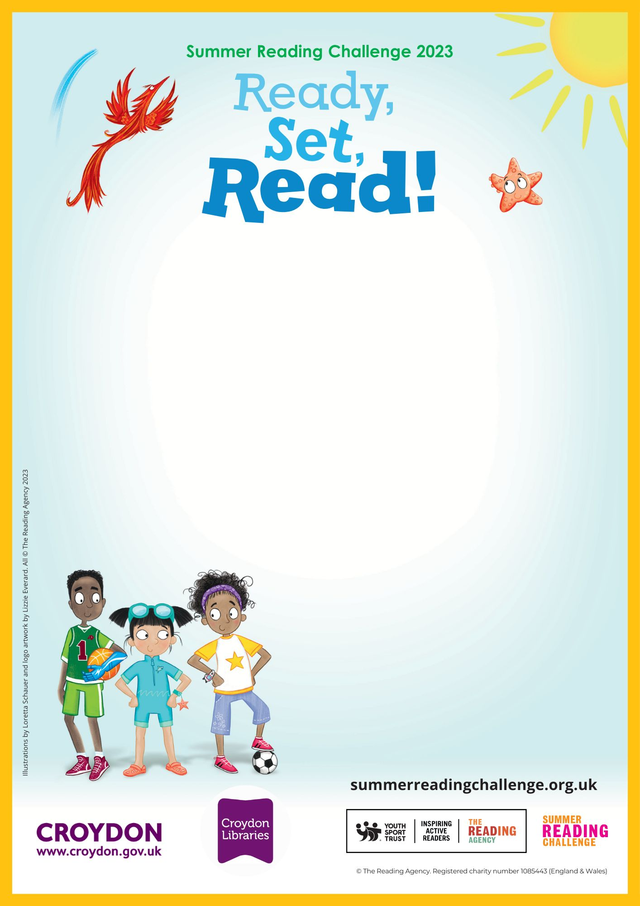
Come and spot the ‘Ready Set Read’ characters located outside and inside of the library. Can you find their names and the answers to the jokes?
Mon 24th July-Friday 8th September
Sanderstead Library

Croydon Library
Katharine Street, Croydon, CR9 1ET
020 7884 5140
croydoncentrallibrary@croydon.gov.uk
Outside-Inside Character Hunt

