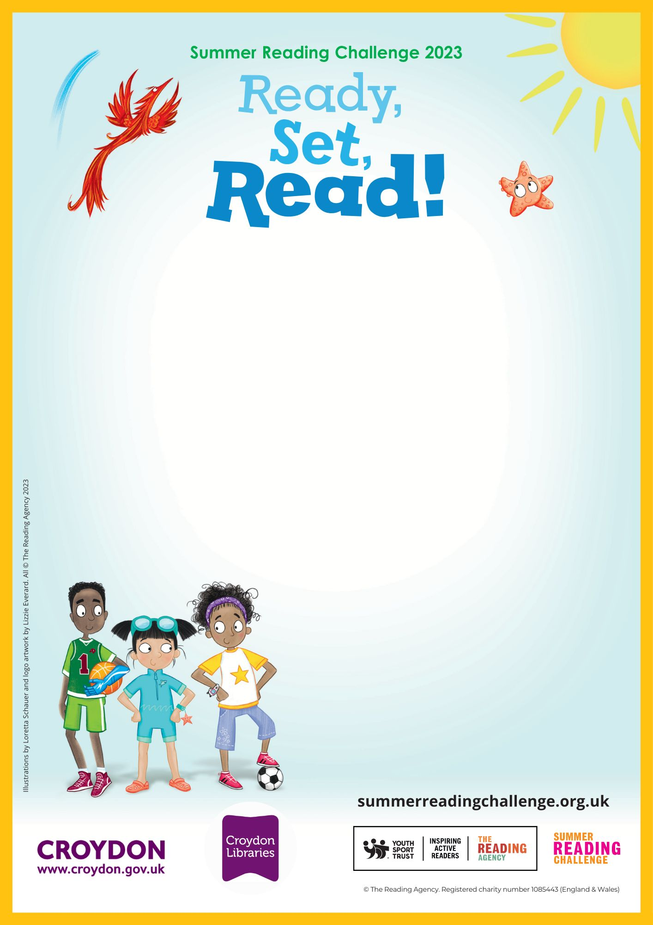
Sports Puzzling and Colouring in for Children

Friday 21st July-all day
Sanderstead Library

Come and make your own puzzle or do our sports themed ones
Croydon Library
Katharine Street, Croydon, CR9 1ET
020 7884 5140
croydoncentrallibrary@croydon.gov.uk

