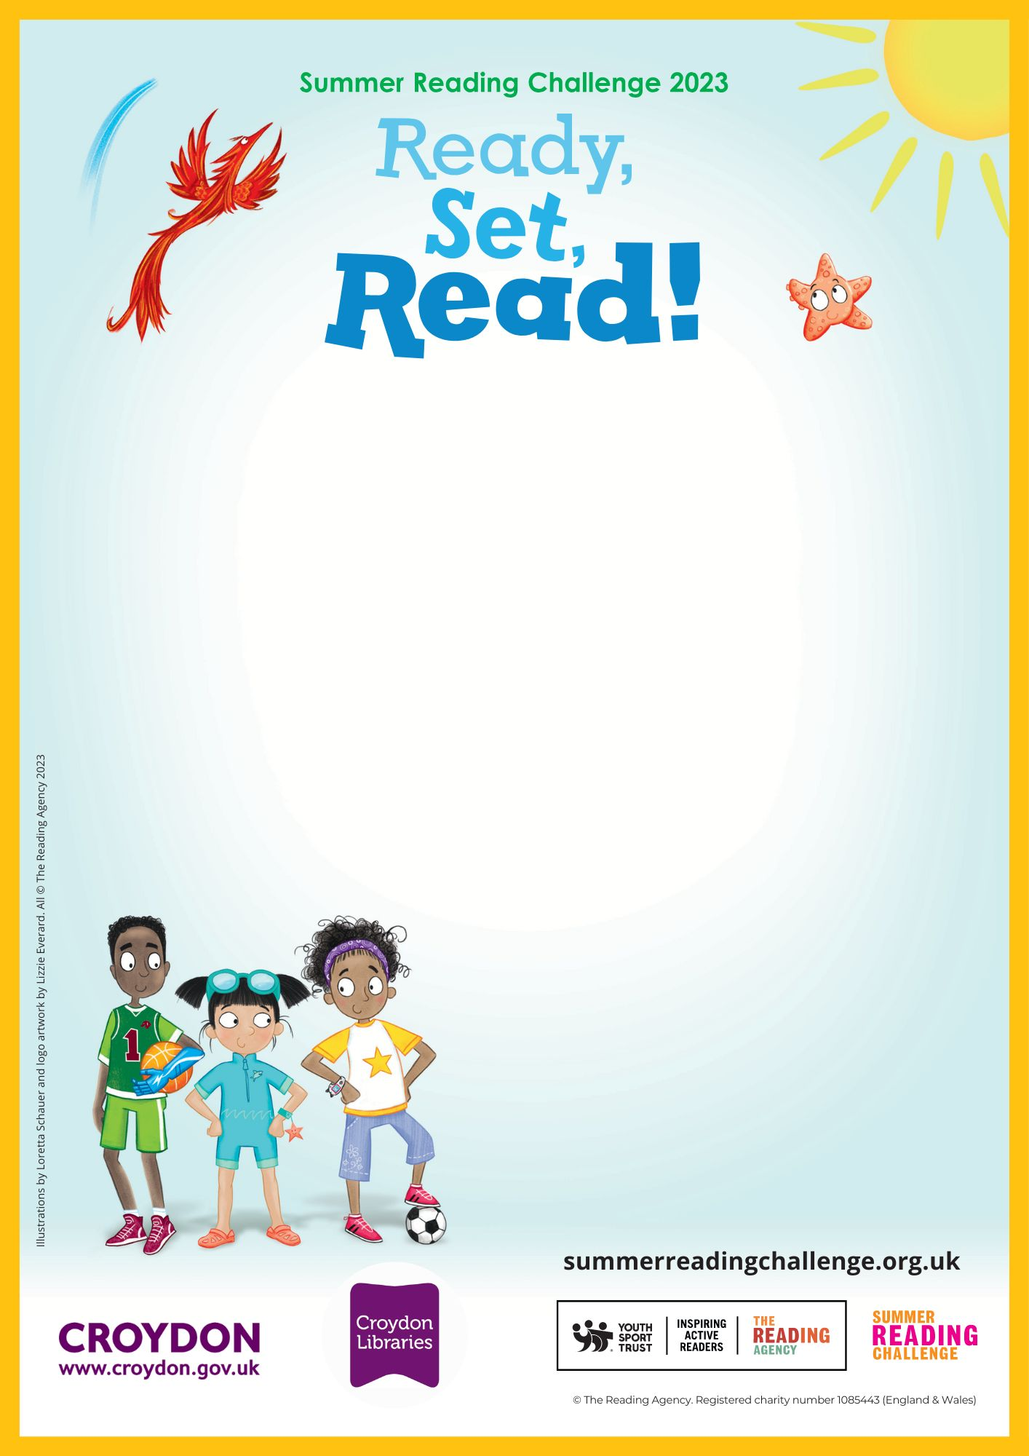
Wednesday 26th July 4pm
Friday 28th July 10.30am

Sanderstead Library

Come and listen to some sporty stories
Croydon Library
Katharine Street, Croydon, CR9 1ET
020 7884 5140
croydoncentrallibrary@croydon.gov.uk
Sporty Storytime for ages 4+

