CROYDON TRADING STANDARDS – NTS Scams Campaign
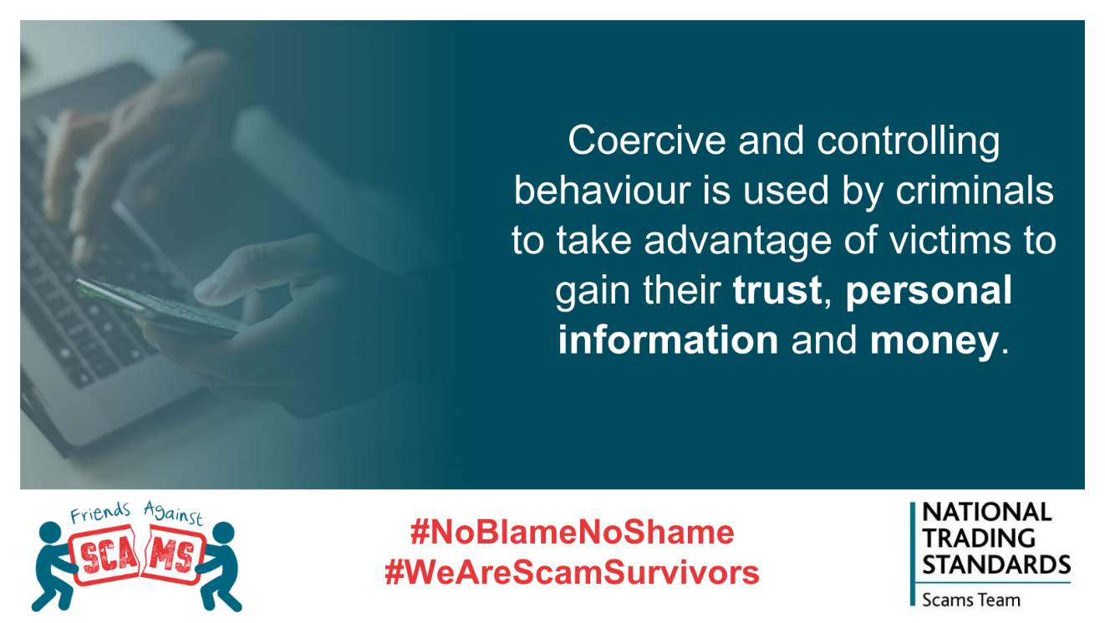
Being a victim of fraud, scams and financial abuse can destroy parts of victims’ lives, including their:
➡Home
➡Health
➡Employment
➡Relationships
Read more here: www.friendsagainstscams.org.uk/noblamenoshame

