CROYDON TRADING STANDARDS
COMMUNITY ALERT
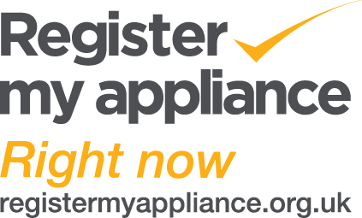
AMDEA is the Association of Manufacturers of Domestic Appliances, the UK trade association that represents over 85% of all small and large domestic appliances sold in the UK. Products include most of the UK’s top selling brands of major white goods, other large and small kitchen appliances, heating, water heating, floor care, waste disposal and ventilation equipment.
You can register your appliance on the website to ensure you:

Never miss out on appliance recalls
Be the first to know of any safety repairs or recalls
Improve your after sales service
Keep in touch with upgrade news

Simply register new & older models here...
If you’ve just purchased, register right now
Check the details of your older appliances. Most brands will let you register these too
https://www.registermyappliance.org.uk/registration/

If you need advice in regards to a purchase or have issues with a trader, please report to Citizens Advice Consumer Advice Line on 0808 223 1133 or go to the following website to report online:
https://www.citizensadvice.org.uk/consumer/get-more-help/if-you-need-more-help-about-a-consumer-issue/

